This document is designed to describe the operations of the TP-Link devices in the SmartThings application. It is a single document for all supported devices. A separate file, “TP-Link Server Installation.txt” provides installation instructions.

Contents:

Supported Devices, Device Handlers, and Functionality

Functional Description

Error Indications and Corrective Actions

Energy Monitor Functions (HS110 only)

# Supported Devices, Device Handlers, and Functionality

Supported devices and test status:

1. SmartThings Device Handler: " TP-Link_HS_Series_v3.groovy".

Functions: on/off; refresh.

a. HS100 - tested.

b. HS105 - not tested. Assume same as HS-100.

c. HS110 - not tested. NO energy monitor. Assume same as HS-100.

d. HS200 - tested.

2. SmartThings Device Handler: "TP-Link_LB100_110_v3.groovy"

Functions: on/off; brightness; refresh.

a. LB100 - function tested on LB-120/LB130. Assume operates.

b. LB110 - function tested on LB-120. Assume operates.

3. SmartThings Device Handler: "TP-Link_LB120_v3"

Functions: on/off; brightness; color temperature; circadian; refresh.

1. LB120 - tested.

4. SmartThings Device Handler: "TP-Link_LB130_v3.groovy"

Functions: on/off; brightness; color temperature; circadian; color; refresh.

1. LB130 - tested.

5. SmartThings Device Handler: "TP-Link_HS110_v3.groovy"

Functions: on/off, refresh, current power, todays consumption, weekly and monthly energy statistics.

1. LB110 – tested by community user.

Optional TP-Link Bridge Interface. The “TP-LinkServer.js” node file includes interfaces to the “TP-LinkBridge.groovy” device handler. This independent applet provides the state of the “TP-LinkServer.js” node applet plus a means to reboot the server. Although the bridge interface is implemented, it is not required for any device control / status function to work. A separate GitHub repository contains the TP-LinkBridge files and description.

**State Machine**. The application is designed as a state machine. In this implementation, setting the device through SmartThings will send a command through the NodeServer to the device. The device then returns the state that is used by SmartThings to update the internal (displayed) state based. The only exception are the power transition states of "TURNINGON" and "TURNINGOFF"; which are set internally to this application.

# Functional Description

This section is in reference to the main screen for each device (accessed by depressing the device label (name) on the SmartThings application. Below is the main screen for the LB-130 bulb. All others are derived from subtracting from this main screen.

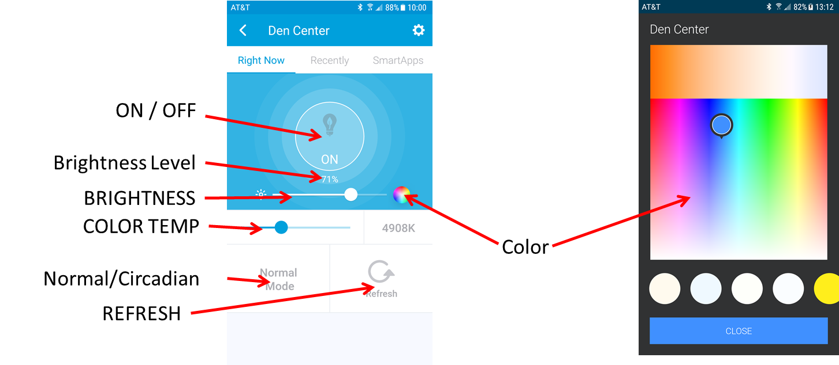

**Function: On/Off**

Applicable: All.

Action: Touch the on-off button to toggle power.

Display states:

a. **ON. Color is blue.**

b. **WAITING** – SmartThings sent a command to the device and is waiting for the return state from the device. **Color is** **green**. Applies to all commands.

c. **OFF. Color is white.**

e **Comms Error** – There is an error in the bridge to device communications stream. **Color is orange**. Applies to all commands.

Notes (bulbs only):

1. Off. Turning bulb off when in circadian mode will also set the bulb to normal mode (this is a bulb function).
2. On. When turning on the bulb, it will turn on to the setting at the last off state. Exception: see above.

**Function: Brightness**

Applicable: All bulbs.

Action: Touch and slide the slider to change brightness.

Display: Displays the interger value of bulb brightness (0 - 100).

Notes:

1. If the bulb is off, changing the brightness will turn on the bulb at the new brightness.
2. For the above, if the bulb is was color when turned-off, it will return to the previously selected color.
3. If you change the brightness to “0”, the bulb will go to the lowest possible brightness; however, the status will state brightness as “0”.
4. If the brightness is “0” and you turn on the bulb, the bulb will act as above.

**Function: Color Temperature**

Application: LB-120 and LB-130 bulbs.

Color Temperature Ranges:

a. LB-120: 2700 to 6500.

b. LB-130: 2500 to 9000.

Action: Touch and slide the slider to change color temperature.

Notes:

1. If the bulb is off, changing the color temperature will turn on the bulb.
2. On the LB-130, the color temperature will appear as zero when a color has been selected.
3. On the LB-130, changing color temperature from zero will return the bulb to non-color at the selected color temperature.

**Function: Circadian (and Normal)**

Application: LB-120 and LB-130 bulbs.

Action: Touch the tile labeled “Normal” to toggle to Circadian.

Notes:

1. Selecting Circadian will automatically turn the bulb on.
2. Circadian emulates outside light levels by controlling brightness and color temperature.
3. Turning the bulb off will also transition the bulb to Normal (this is a bulb function).

**Function: Color Temperature**

Application: LB-130 bulb.

Action: Touch the color wheel on the power tile. Then select the desired color either by touching the desired color on the color tile or selecting the preset color at the bottom of the page.

Notes:

1. If the bulb is turned off, the bulb will automatically turn on when selecting a color.
2. Selecting Circadian or changing the color temperature will return the bulb to non-color.

**Function: Refresh**

Applicable: All.

Action: Touch the Refresh button. This will update the state of the device from the device.

Use: Automatically run every 15 minutes. Occasional user use if the device state does not match the device state.

**ERROR INDICATIONS AND CORRECTIVE ACTIONS**

Applicable: All. The SmartThings application display provides a four color status display. Two of these colors encompass the potential error conditions

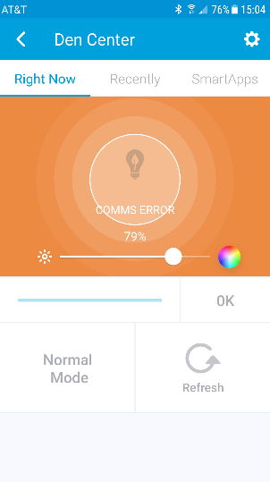**COMMS ERROR**. Indicated by ON/OFF being a steady orange with the cue “COMMS ERROR”. This indicates that the Bridge device is unable to communicate with the TP-Link device.

Corrective Actions to try:

* 1. Press REFRESH on the device being controlled.
  2. Go to the TP-LinkBridge device (if installed) and check the status.
  3. Turn the TP-Link device off then on. Wait about a minute and try again.
  4. Check the TP-Link device IP address and assure it has not changed.

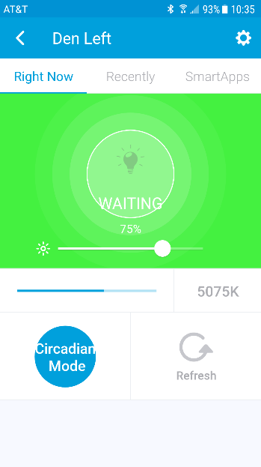**WAITING**. Indicated by ON/OFF being a steady green and the cue “WAITING”. This indicates that SmartThings attempted to send a command, but no response was received from the bridge (and device). There are several possible conditions for this error:

1. If the device responded to the command, the error is either in the TP-LinkSerrver.js application or the SmartThing cloud (both have occurred).
2. If the device is did not respond, the problem is either SmartThings not actually sending the command or that SmartThings did not communicate with the bridge.

This is indicated by the On/Off button being a steady orange and the message “TURNING ON” or “TURNING OFF”. The cause is that the TP-Link device is off-line.

Corrective Actions to try:

* + 1. Press REFRESH on the device being controlled. If corrected, it is probably transitory.
    2. Try another device.
    3. Check the bridge device hardware and software status; including, the log file (looking for error conditions).
    4. Check the bridge device IP for potential change.

**Energy Monitor Functions (HS110 only)**

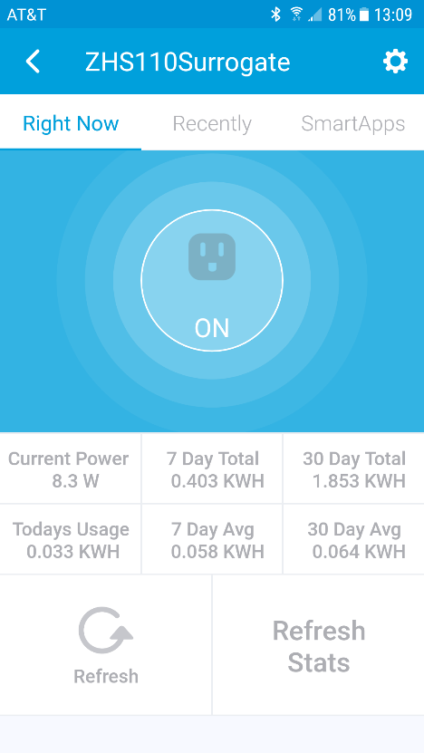Energy monitor functions have been added to the HS110 device handler. This function works only with the HS110 plug and (although it will work for on/off) it will generate an error on the other plugs and switches. The following tiles are added:

1. Current power in watts.
2. Today’s Usage in kilo watt-hours.
3. 7 Day Total
4. 7 Day Average
5. 30 Day Total
6. 30 Day Average.

The Refresh function will refresh the bulb state as well as update the Current Power and Today’s Usage tiles. Refresh is scheduled every 15 minutes and can also be activated manually.

The new Refresh Stats function will update the weekly and monthly stats. This is scheduled to run at 12:30 AM every day. It can also be manually updated.